

Subscribe to DeepL Pro to edit this document.  
Visit [www.DeepL.com/pro](https://www.deepl.com/pro?cta=edit-document)for more information.

# Correlations between the U.S.-China economic cycle and trade frictions and suggestions

Yuqing Wang

Abstract: Economic cycle fluctuations are an important feature of national economic operation, and the economic cycles of various countries have certain synergies, and the study of economic fluctuations is of great significance for understanding economic operation. China and the United States are each other's top trading partners, and frequent trade exchanges in recent years have led to increasing trade frictions between the two countries. Studying the causes and transmission mechanisms of the emergence of economic cycle synergy between China and the United States, and understanding and grasping the relevance, long-term nature and complexity of the economic downward pattern and trade frictions between China and the United States can help the government to take timely and reasonable policies and measures to deal with trade frictions.

Keywords: economic cycle; U.S.-China trade friction; economic policy

Author Affiliation: Northern Polytechnic University

##### Key features of the US and Chinese economic cycles

###### Four stages of China-US comparative analysis

* + 1. China

The cyclical fluctuations of China's economy can be divided into four typical stages: the first stage was from 1960 to 1970, when the economy was characterized by large fluctuations; the second stage was from 1970 to 1978, when the economy was in a downward trend; the third stage was from 1978 to 1988, when China began to implement the reform and opening-up policy and the economy was in a continuous high growth trend; the fourth stage was from 2008 to 2019 The fourth stage is 2008-2019, affected by the financial crisis and other factors, the economy shifted to medium-high growth under the new normal and was in a gradual decline.

* + 1. United States

The cyclical fluctuations of the U.S. economy can also be divided into four typical phases: the first phase was from 1960 to 1973, when the economy was in an upward trend; the second phase was from 1974 to 1982, when the economy was characterized by a downturn; the third phase was from 1983 to 2000, when the economy was in an upward trend; and the fourth phase was from 2008 to 2019, triggered by the subprime mortgage crisis, when the economy as a whole was in a downturn The fourth phase is from 2008 to 2019, triggered by the subprime mortgage crisis, and the economy as a whole is in decline.

###### Causes of the Emergence of Synergy in the U.S.-China Economic Cycle

In recent years, China and the U.S. have enjoyed close economic and trade ties, and the pace of the economic cycle has become increasingly convergent.

* + 1. China's growing integration into the world economy

With the increasing development of global economic integration, cooperation among different economies has been gradually strengthened. After China's accession to the WTO, its economic ties with other countries in the world have become increasingly close, and the rapid development of foreign trade and increasing dependence on foreign trade have resulted in a significant convergence of economic cycle fluctuation trends with economies such as the US. This indicates that China's deepening integration into economic globalization has provided the preconditions for the mutual influence of economic cycles.

At present, in the midst of a significant reduction and downturn in global outward direct investment, foreign direct investment in China is still steadily expanding and maintaining a relatively fast growth momentum, reflecting the fact that China is deeply involved in the process of economic globalization and has increasing economic ties and influence with other countries around the world.

* + 1. The linkage and transmission of trade and direct investment links between China and the United States

With increased globalization, mutual import and export trade and investment play a fundamental role in the formation of the synchronization of economic cycle fluctuations between countries. The synchronization of economic cycle fluctuations between China and the U.S. at certain stages is a result of the increasingly close trade and investment ties between the two countries. Since China's accession to the WTO, China and the U.S. have become increasingly close in economic and trade relations, and trade volume has continued to climb, from $80.485 billion in 2001 to $583.697 billion in 2017, with a CAGR of 13.2%, especially during the period 2000-2008, when China-U.S. trade volume always maintained double-digit growth. In terms of the structural share of total trade, China and the U.S. are each other's top trading partners, and the share of China-U.S. trade in China's total trade has always exceeded 12%, and the share of both exports and imports is also at a stable level, at 18.99% and 8.36% respectively in 2017.

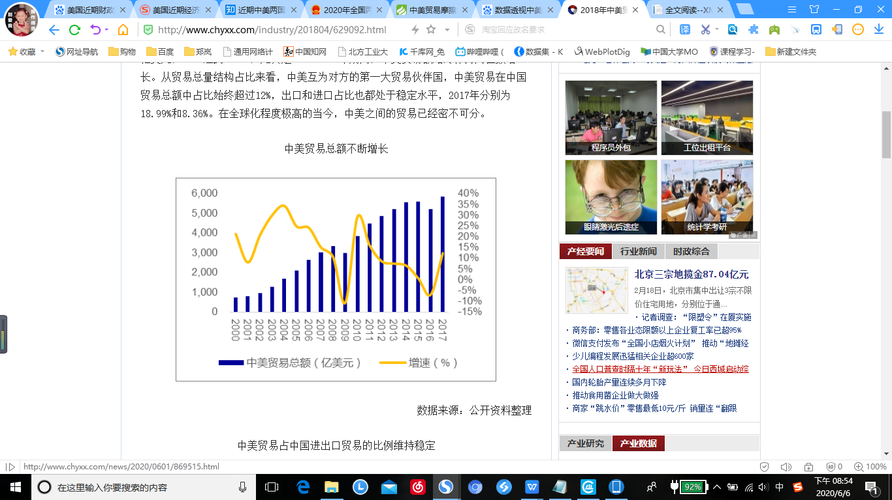

* + 1. Synergistic development is the general trend

China and the United States has become the locomotive that drives the world's economic growth, and in recent years, although the wave of Sino-US trade twists and turns, but the characteristics of economic globalization determines the general trend of countries to develop in concert and build a community of human destiny.

It is of great practical importance to explore the trends and patterns of the development of the economic cycles of China and the United States, especially the synchronization of the fluctuations of the economic cycles of the two countries and their transmission mechanisms, so as to better understand the economic interconnection and mutual influence of the two sides, thus providing important theoretical support for better economic and trade cooperation and promoting the common prosperity of the two economies.

1. Correlation Analysis of U.S.-China Trade Friction and Economic Cycle
   1. Analysis of the current situation
      1. Large amount and high proportion of trade friction between China and the United States

Since China's accession to the WTO, total imports and exports have grown rapidly, and the trade balance has become one of the important factors affecting trade relations between China and the United States. From 2006 to 2016, the total trade volume between China and the United States and the trade surplus between China and the United States rose significantly, but the rise in the number of cases involving trade frictions between China and the United States was even greater and has become the norm. in 2019, China's imports and exports to the United States were 3.73 trillion yuan, down 10.7%. The ultra-high amount of U.S.-China trade frictions compared to the total U.S.-China trade is bound to lead to increasingly frequent U.S.-China trade frictions.

2.1.2 China-US trade frictions involving product categories continue to renovate

Since 2010, Sino-US trade frictions have entered an escalating stage, involving product categories gradually shifting from labor-intensive products to technology-intensive products. As of 2019, the number of cases in which China's technology-intensive products were subject to anti-dumping investigations was 584, accounting for 73% of the total number of cases of trade friction between China and the United States. At the same time, along with the faster development of science and technology in China, trade frictions between China and the United States also began to involve high and sophisticated products.

2.1.3 Increasing diversification of U.S. trade friction tactics against China

The U.S. real economy has been declining in the post-financial crisis phase, and in order to secure domestic market share, the U.S. has adopted a series of policies to restrict imports or encourage exports, and the means of trade friction with China have become increasingly diverse.

On the one hand, the U.S. uses anti-dumping to hinder imports of goods from China in the chemical, steel, and electromechanical industries to maintain the share of its own industries in the domestic market. In recent years, anti-dumping is the main means for the U.S. to hinder the import of Chinese goods, and the proportion of the number of anti-dumping investigations against China has been increasing.

On the other hand, technical and green trade barriers are also one of the major impediments to trade between the United States and China. The discriminatory trade consequences caused by technical and green trade barriers are often overshadowed by their legitimate environmental protection reasons. In recent years, the U.S. has enacted a series of relevant trade protection laws and trade guidelines, and many of China's goods are banned from exporting to the U.S. because they have difficulty meeting U.S. environmental requirements standards, creating many trade frictions.

* 1. Downward economic cycles are positively correlated with trade frictions

In recent years, the world economic growth is sluggish, market dynamics show a declining trend, is gradually evolving into a general economic down cycle; at the same time, the market recession will intensify industrial competition, the risk of trade friction gradually increasing, the positive correlation characteristics are increasingly significant. Specifically, the economic downturn cycle, one is the survival of micro enterprises with pro-cyclical characteristics, the deterioration of the external market environment will increase the survival pressure of enterprises; second, the overall level of social welfare reduced, social conflicts intensified, and the bilateral trade balance caused by the distribution of trade welfare issues more frequent trade frictions.

Currently, one of the main excuses for the U.S. to provoke trade friction is that China's persistent and large trade surplus with the U.S. and the distribution of trade benefits has caused dissatisfaction on the U.S. side. This is an inevitable means for the strong side to get out of its own predicament and contain the development of the other side when China and the United States are in the same economic down cycle.

1. The Longevity and Complexity of U.S.-China Trade Friction

In October 2019, the thirteenth round of high-level economic and trade consultations between China and the United States reached a preliminary "first stage" trade agreement, making substantial progress in areas such as agriculture, intellectual property protection, exchange rates, financial services, expanding trade cooperation, technology transfer and dispute settlement. However, it is also important to see soberly that the overall trend of trade friction between the United States and China is to stop fighting, the overall escalation of the situation, and the gradual expansion of the field. The current is only a phase of easing rather than the end, trade friction will remain for a long time.

* 1. The U.S. is suppressing China in different areas

In the economic and trade field, the U.S. has been increasing the scale and rate of tariffs imposed on China, and the signing of the U.S.-Canada-Mexico Free Trade Agreement (FTA) has set up a "poison pill clause" against China. In the financial sector, the U.S. has launched investigations into Chinese banks, forcibly identified China as a "manipulator of exchange rates", and recently has plans to prevent Chinese companies from going public in the U.S., ban U.S. pension funds from investing in the Chinese market, and include the RMB exchange rate in the negotiation agreement. In the field of science and technology, the U.S. has taken measures to suppress high-tech enterprises such as Huawei, Haikang and Dahua, demonstrating its intention to contain China's high technology. In the area of international organizations and rules, the U.S. does not recognize China's market economy and developing country status, among others, and unilaterally pressures the WTO to revise international rules, even breaking the system it has established itself when its real interests are offended.

* 1. China is pushing forward with high quality development

Socialism with Chinese characteristics has entered a new era. Promoting high-quality development is the fundamental requirement for determining development ideas, formulating economic policies and implementing macro-control in the current and future period. It must be soberly recognized that the huge gap between China and the United States in the fields of science and technology innovation, high-end manufacturing, financial services, university education, military strength, etc.; there is still a lot of work to be done in the fields of reducing investment restrictions, lowering tariffs, protecting property rights, and reforming state-owned enterprises. In the future, China will slowly tighten and retract the over-issued money released to real estate investment and off-balance-sheet finance, and gradually shrink the table, so that the new money will really flow to the real industries and real economy on the supply side, accelerate deleveraging and dissolve overcapacity, and promote industrial transformation and upgrading.

The latest government work report also points out that the active fiscal policy is more active and active; the prudent monetary policy is more flexible and moderate. This will provide strong support for high-quality development China to promote high-quality development.

1. Conclusions and Recommendations

With the US-China trade friction as the symbol, trade friction with China is intensifying, and more countries and regions are actively (or passively) involved in it, the prospect of economic globalization is overshadowed, and the world economy will enter a lasting downward cycle. At the same time, China's economy is also facing the challenges of a new normal, with slowing economic growth, sluggish external market demand and trade frictions between China and the U.S., forcing China to change its economic development mode and deepen its outward-looking development strategy as the primary goal of policy regulation. Under the complex and severe economic and political situation, the frequency and intensity of policy interventions have increased significantly, and the influence of the "visible hand" on resource allocation has become particularly important.

4.1 Active response with the power of WTO

Emphasis on the use of the WTO mechanism, the WTO plays a great role in solving the trade problems of the two countries. Now that China has been in the WTO for many years, it should properly use its rights as a member country to defend its interests and take the initiative to take measures to defend its rights and interests and defend its equal status in trade.

4.2 Use government functions to grind

In order to better resolve the trade friction between China and the U.S., we should strengthen the communication between the two governments and proactively resolve the trade dispute. We should strengthen the exploration of methods to solve the trade friction between China and the U.S., closely track the direction of U.S. fiscal and monetary policies, and make policy reserves and response plans in advance.

4.3 Promote mutual communication among trade agencies

Improve the efficiency of trade friction handling by strengthening communication between trade departments. Facing different problems quickly contact to the corresponding department for coordination, in order to obtain the principle of maximizing cost effectiveness, by taking active measures to achieve the purpose, obtain better coordination effect and avoid economic waste.

4.4 Increase the opening to the outside world

In terms of strategy, China's most important diplomatic relationship is the U.S.-China relationship, the essence of which is the question of the mode of relationship between the emerging rising power and the reigning hegemonic power. China needs to establish and preach a good vision and advanced civilization with wide appeal to people all over the world against the backdrop of the U.S. return to the hegemonic mindset of prioritizing its own interests; go to the world with a more open attitude against the backdrop of the U.S. return to trade protectionism; and establish a free trade system with Southeast Asia, Europe, Japan, Korea, and Central Asia in a comprehensive and in-depth manner against the backdrop of the U.S. war on all sides to achieve win-win cooperation.

Reference.

[1] Tian Suhua, Xie Zhiyong. A study on the differences and synergies of economic cycle fluctuations between China and the United States[J]. World Economic Research,2020(03):72-94+136-137.

[2] Jia Yucheng,Lu Jingwei. Do economic cycles and economic policy uncertainty drive trade frictions[J]. The Economist,2020(03):75-86.

[3] Li Xiaoli. The impact of trade goods category on the economic cycle co-mobility of China and the United States[J]. Statistics and Decision Making,2019,35(21):139-142.

[4] Jia Yucheng, Chang Han. Economic cycle, economic policy uncertainty and trade frictions with China--From China-US trade frictions[J]. Journal of Shanghai University of International Business and Economics,2019,26(03):58-68.

[5] Li Xing, Chen Xiaohu, Zou Zhangyong. A study on the trade transmission mechanism of U.S. to China's economic cycle and its phase effects[J]. Statistics and Decision Making,2019,35(02):126-130.

[6] Dong Wenzhuo, Zou Qiang. Policy choices in the divergent phases of the US-China economic cycle[J]. Bond,2019(01):81-85.

[7] Han Chuan. An analysis of the causes of the economic cycle mismatch between China and the United States [J]. Contemporary Economic Science,2017,39(05):107-111+128.

[8] Cai Qunqi, Gong Min. Analysis of the volatility characteristics of China's economic cycle--a comparison based on China, the United States, Japan and Korea[J]. Exploration of Economic Issues,2017(04):18-25.

[9] Shen Ji, Cao Xing. Analysis of economic cycle co-mobility between China and the United States[J]. Economics and Management,2011,25(12):9-15.